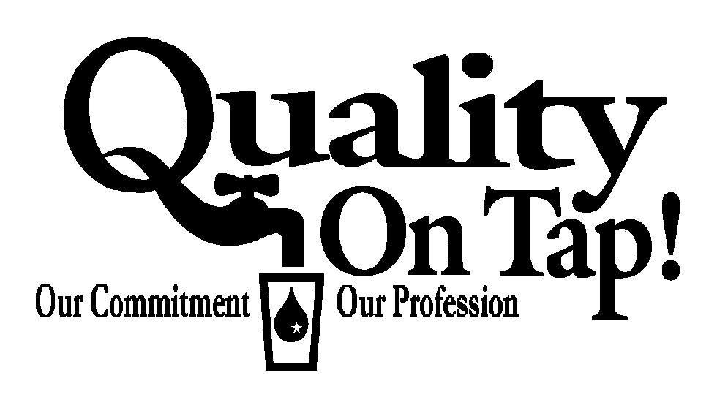
2025 Annual Consumer Confidence Report

Upper La Plata Mutual Domestic Water Users

We are pleased to present this year's Annual Consumer Confidence Report. This report is designed to keep you informed about the water quality and services we deliver every day. Our constant goal is to provide you with a safe and dependable supply of drinking water. We want you to understand the efforts we make to continually improve the water treatment process and protect our water resources. We are committed to ensuring the quality of your water. Our water source is treated surface water from the San Juan and Animas Rivers, purchased from Lower Valley Water Users. In emergencies from The City of Farmington.

The Associations Source Water Assessment & Protection Report is available for viewing at our office and provides more information on potential sources of contamination.

If you have any questions about this report or concerning your water utility, please contact your State Certified Operators Larry Kennedy, Chance Fuller, and Jeremey Lowenstein at 505/324-7368, or any of your Board members. President Chad King at 505/325-4718, Vice President Steven Dunn at 505/325-8907, Secretary/Treasurer Melissa Montoya at 505/320-6200, Board Member Barbra Whitmore 505/326-1381 or Board Member Charles Blassingame at 505/326-4914. We want our valued customers to be informed about their water utility. If you want to learn more, please attend any of our regularly scheduled meetings. They are held on the third Tuesday of each month at 5.30 P.M. at our office located at 1438 NM Hwy 170.

Domestic Water Consumer’s Association routinely monitors for constituents in your drinking water according to Federal and State laws. The following table shows the results of this monitoring for the period of January 1 through December 31, 2025. As water travels over the land or underground, it can pick up substances or contaminants such as microbes, inorganic and organic chemicals, and radioactive substances. All drinking water, including bottled drinking water, may be reasonably expected to contain at least small amounts of some constituents. It is important to remember that the presence of these constituents does not necessarily pose a health risk. More information about contaminants and potential health effects can be obtained by calling the Environmental Protection Agency’s Safe Drinking Water Hotline at 1-800-426-4791. The sources of drinking water (both tap water and bottled water) include rivers, lakes, streams, ponds, reservoirs, springs and wells. As water travels over the surface of the land or through the ground, it dissolves naturally occurring minerals and, in some cases, radioactive material, and can pick up substances resulting from the presence of animals or from human activity: microbial contaminants, such as viruses and bacteria, that may come from sewage treatment plants, septic systems, agricultural livestock operations, and wildlife; inorganic contaminants, such as salts and metals, which can be naturally occurring or result from urban stormwater runoff, industrial, or domestic wastewater discharges, oil and gas production, mining or farming; pesticides and herbicides, which may come from a variety of sources such as agricultural, urban stormwater runoff and residential uses; organic Chemical Contaminants, including synthetic and volatile organic chemicals, which are by-products of industrial processes and petroleum production and can also come from gas stations, urban stormwater runoff and septic systems; and radioactive contaminants, which can be naturally occurring or be the result of oil and gas production and mining activities. In order to ensure that tap water is safe to drink, EPA prescribes regulations that limit the amount of certain contaminants in water provided by public water systems. Food and Drug Administration (FDA) regulations establish limits for contaminants in bottled water which must provide the same protection for public health.

We are pleased to report that our drinking water is safe and meets federal and state requirements.

In 2025, our system had no violations. We are proud that your drinking water meets or exceeds all Federal and State requirements. We have learned through our monitoring and testing that some constituents have been detected. The EPA has determined that your water IS SAFE at these levels.

Some people may be more vulnerable to contaminants in drinking water than the general population. Immuno-compromised persons such as persons with cancer undergoing chemotherapy, persons who have undergone organ transplants, people with HIV/AIDS or other immune system disorders, some elderly, and infants can be particularly at risk from infections. These people should seek advice about drinking water from their health care providers. EPA/CDC guidelines on appropriate means to lessen the risk of infection by cryptosporidium and other microbiological contaminants are available from the Safe Drinking Water Hotline (800-426-4791)

The system inventory does not include lead service lines.
Lead and Copper tests were performed as required.

If present, elevated levels of lead can cause serious health problems, especially for pregnant women and young children. Lead in drinking water is primarily from materials and components associated with service lines and home plumbing. Upper La Plata Domestic Water Consumers and Mutual Sewage Works is responsible for providing high quality drinking water, but cannot control the variety of materials used in plumbing components. You share the responsibility for protecting yourself and your family from the lead in your home plumbing. You can take responsibility by identifying and removing lead materials within your home plumbing and taking steps to reduce your families risk. When your water has been sitting for several hours, you can minimize the potential for lead exposure by flushing your tap for 30 seconds to 2 minutes before using water for drinking or cooking. If you are concerned about lead in your water, you may wish to have your water tested, contact Upper La Plata Domestic Water Consumers and Mutual Sewage Works (Public Water System ID: NM35-106-24) by calling (505) 326-1751 or emailing laplatawaterusers@gmail.com. Information on lead in drinking water, testing methods, and steps you can take to minimize exposure is available from the Safe Drinking Water Hotline or at http://www.epa.gov/safewater/lead.

In the subsequent table you will find many terms and abbreviations you might not be familiar with. To help you better understand these terms we are providing the following definitions:
HLRAA Highest Locational Running Annual Average
ppm Parts Per Million or mg/l Milligrams Per Liter - one part per million corresponds to one minute in two years or a single penny in $10,000.
ppb Parts Per Billion or Micrograms Per Liter - one part per billion corresponds to one minute in 2,000 years, or a single penny in $10,000,000.
ug/L number of micrograms of substance in one liter of water.
pCi/L -Picocuries Per Liter - (a measure of the radioactivity in water.)
NTU Nephelometric Turbidity Unit- is a measure of the clarity of water. Turbidity in excess of 5 NTU is just noticeable to the average person.
TT Treatment Technique – A required process intended to reduce the level of a contaminant in drinking water.
AL Action Level-The concentration of a contaminant which, if exceeded, triggers treatment or other requirements which a water system must follow.
MCL Maximum Contaminant Level - The “Maximum Allowed” is the highest level of a contaminant that is allowed in drinking water. MCLs are set as close to the MCLGs as feasible using the best available treatment technology. MCL’s are set at very stringent levels. To understand the possible health effects described for many regulated constituents, a person would have to drink 2 liters of water every day at the MCL level for a lifetime to have a one-in-a-million chance of having the described health effect.
MCLG Maximum Contaminant Level Goal - The “Goal” is the level of a contaminant in drinking water below which there is no known or expected risk to health. MCLGs allow for a margin of safety.
MRDLG Maximum Residual Disinfection Level Goal - The level of a drinking water disinfectant below which there is no known or expected risk to health. MRDLGs do not reflect the benefits of the use of disinfectants to control microbial contaminants.
MPL State Assigned Maximum Permissible level.
MNR Monitored Not Regulated.
N/A Not Available or Applicable
TEST RESULTS
Contaminant | Violation |  |  | Sample  Date |  | Level  Detected |  |  | Range of Detection |  |  | Unit |  |  | MCLG, TT  or  MRDLG |  |  | MCL, AL, or  MRDL |  |  | Likely Source of Contamination
Total Organic Carbon  (% Removal) | NO |  |  | 2023 |  | 2.4 |  |  | N/A |  |  | Mg/l |  |  | TT |  |  | N/A |  |  | Naturally occurring in the earth

Microbiological Contaminants
Coliform Bacteria | NO |  | 2025  Monthly |  |  |  | 0 |  |  | 0 |  |  |  |  |  | 0 |  | 0 |  |  | Naturally present in the environment
Turbidity (NTU) | NO |  | 2025  Jan-Dec |  |  |  | 99 |  |  | N/A |  |  | NTU |  |  | N/A |  |  | 0.3 |  | Soil runoff

99% of the samples were below TT value of .3. A value less than 95% constitutes a TT violation. The highest single measurement was 0.3. Any measurement in excess of 1 is a violation unless otherwise approved by the State.
Inorganic Contaminants |  |  |  |  |  |  |  |  |  |  |  |  |  |  |  |  |  |  |  |  |  |  |  |  |  |  | NTU
Fluoride | NO |  | 2025 |  |  |  | 0.029 |  |  |  | 0.029 |  | ppm |  |  | 4 |  |  | 4 |  | Erosion of natural deposits; water additive  which promotes strong teeth; discharge from  fertilizer and aluminum factories
Copper | NO |  | July  2024 |  |  |  | 0.31 |  |  |  | 0.04-0.33 |  | ppm |  |  | 1.3 |  |  | 1.3 |  | Corrosion of household plumbing systems; erosion of natural deposits; leaching from wood preservatives
Lead | NO |  | July  2024 |  |  |  | 0.6 |  |  |  | 0 – 1.4 |  | ppb |  |  | 0 |  |  | 15.00 |  | Corrosion of household plumbing systems, erosion of natural deposits
Barium | NO |  | 2025 |  |  |  | 0.065 |  |  |  | 0.0-0.065 |  | ppm |  |  | 2 |  |  | 2 |  | Discharge of drilling wastes;  Discharge from metal refineries;  Erosion of natural deposits.
Nitrate - Nitrite | NO |  | 2025 |  |  |  | 0 |  |  |  | N/A |  | Mg/l |  |  | 10.0 |  |  | 10.0 |  | Runoff from fertilizer use;  Leaching from septic tanks;  Erosion of natural deposits.
Selenium (ppb) | NO |  | 2025 |  |  |  | 0.005 |  |  |  | 0.0-0.005 |  | ppb |  |  | 50 |  |  | 50 |  | Discharge from petroleum and metal refineries,  Erosion of natural deposits,  Discharge from mines.
Disinfectants and Disinfection Byproducts |  |  |  |  |  |  |  |  |  |  |  |  |  |  |  |  |  |  |  |  |  |  |  | MCL  or  MRDLG
Chlorine | NO | 2025  Monthly |  |  | 0.88 |  |  | 0.4 to 1.7 |  |  |  |  |  | ppm |  |  | 4 |  |  | 4 | Water additive used to control microbes
Haloacetic Acids Stage 2 | NO | 2025 Quarterly |  |  | HLRAA  41 |  |  | 26 to 52 |  |  |  |  |  | ppb |  |  | N/A |  |  | 60 | By-product of drinking water chlorination
TTHM Stage 2  [Total trihalomethanes] | NO | 2025 Quarterly |  |  | HLRAA  67 |  |  | 58.2 to 75.0 |  |  |  |  |  | ppb |  |  | N/A |  |  | 80 | By-product of drinking water chlorination
Radioactive
Alpha emitters | NO |  | Aug  2021 |  |  |  | 2.2 | 2.2 |  |  |  |  |  | pCi/L |  |  | 0 |  |  | 15 | Erosion of natural deposits
Beta/Photon emitters | NO |  | Aug  2021 |  |  |  | 3.6 | 3.6 |  |  |  |  |  | pCi/L |  |  | 0 |  |  | 50 | Decay of natural and man-made deposits
Uranium, mass concentration | NO |  | Aug  2021 |  |  |  | 0 | 0 |  |  |  |  |  | ug/L |  |  | 0 |  |  | 30 | Erosion of natural deposits
Combined radium | NO |  | Aug  2021 |  |  |  | 0.08 | 0.08 |  |  |  |  |  | pCi/L |  |  | 0 |  |  | 5 | Erosion of natural deposits

Additional Contaminants

In an effort to ensure the safest water possible the State has required us to monitor some contaminants not required by Federal regulations. Of those contaminates only the ones listed below were found in your water.

Test Results
Contaminate | Violation | Sample Date | Level Detected | Range of Detection | Unit | MCLG, TT  or  MRDLG | MCL, AL, or  MRDL | Likely Source of Contamination
Lithium | NO | 2023 |  | 14.6 - 36 | ppb | N/A | N/A | N/A

Contaminants | MCLG | AL | Your Water | Range |  | # Samples Exceeding AL | Sample Date | Exceeds AL | Typical Source
 |  |  |  | Low | High
Inorganic Contaminants
Copper – action level at consumer taps (ppm) | 1.3 | 1.3 | 0.31 | 0.04 | 0.33 | 0 | July 2024 | No | Corrosion of household plumbing systems; Erosion of natural deposits
Lead – action level at consumer taps (ppb) | 00 | 15 | 0.6 | 0 | 1.4 | 0 | July 2024 | No | Corrosion of household plumbing systems; Erosion of natural deposits

